**MECHANICAL DESIGN - HARDWARE SPECIFICATIONS**

Author: Kaichen Wang

Date: 28 Feb 2013

Version: 1.0

Notes: Contribution and hardware built by François Parent and Hardware team

**TABLE OF CONTENTS**

**CONSTRAINTS**

As stated in the Constraints document &

“no restrictions on robot size, other than the requirement to be small enough to localize within the starting corner.”

**GENERAL DESIGN**

* General
  + Overview

The philosophy is “Keep it simple, stupid”, but creating an efficient and powerful system which is also clean and simple can lead to challenging design decisions. The difficulty is in recognizing what is essential to creating a successful design and what is superfluous. Superfluous elements are not always obvious to identify in plain sight and complex solutions may at times seem to fit the bill the best.

The way we approach this design challenge is to start with the bare minimum. A PatBot-style base with only one wheel attached to either side of the NXT brick (third wheel is attached at the back end, but is not motorized nor is it a tire). From there, we choose which sensors to attach and which pieces in the Lego kit to incorporate on top of the base. Before any element is added to the mechanical design a general question must be asked: What value does this piece add to the design? (Can this piece’s intended functionality be achieved without adding this piece? / can this piece’s intended functionality be achieved with an equivalent but more efficient piece? / can this piece’s intended functionality be implemented instead using software and existing pieces?)

* + Weight

Undefined at the moment and will require a weigh-in.

* + Dimensions

Wheelbase: 16.5 cm

(Measured distance between the center of each of the two wheel tires)

Length: 26 cm

(Measured distance between the tip attached to the touch sensors and the back of the light sensor)

Max width: 26 cm

(Measured distance between the tips of the attachments on the touch sensors)

Max height: 45 cm

(Measured distance between the bottom of the wheels to the tip of the catapult arm when fully vertical)

* Materials required
  + Equipment from kit

At the moment, the prototype consists only of standard parts includes in the Lego MindStorms kit.

* + - 1 NXT Brick
    - 1 Light sensor
    - 2 Touch sensors
    - 1 Ultrasonic sensor
    - 3 Servo Motors
    - 7 Connector cables
    - Miscellaneous Lego pieces (an .lxf file version of a more finalized prototype will be produced and will account for all Lego pieces used in the design while also providing a detailed step-by-step building schematic)
  + Extra equipment
    - Can pick from “additional bill of materials” document
    - No additional equipment has been procured and integrated to the design at this time (Except AA batteries)
* Robot base

The robot base is based on the PatBot design as provided by the corresponding .lxf file. Two motors are attached horizontally to the NXT brick (one (motor A) of the “left” and one (motor C) on the “right”). One wheel with tire is attached to either motor. The third motor is attached to a vertical structure attached to the NXT brick. The third motor is attached at a 45 -degree angle with the tip pointing upwards and towards the back of the robot. Attached to this motor is a pair of gears (one on each side) which is in turn fixed onto another pair of gears with a smaller diameter. The remainder of the catapult arm is attached to the smaller pair of gears. (See Catapult Mechanism section) Two touch sensors are attached at the front of the robot and should provide first contact with any objects potentially in the way. The light sensor is mounted at the base and at the back of the robot. It points straight at the ground. The ultrasonic sensor is mounted at the base and points directly away in front of the robot. The six batteries of the robot can be removed with a little disassembly of the bottom of the PatBot frame structure.

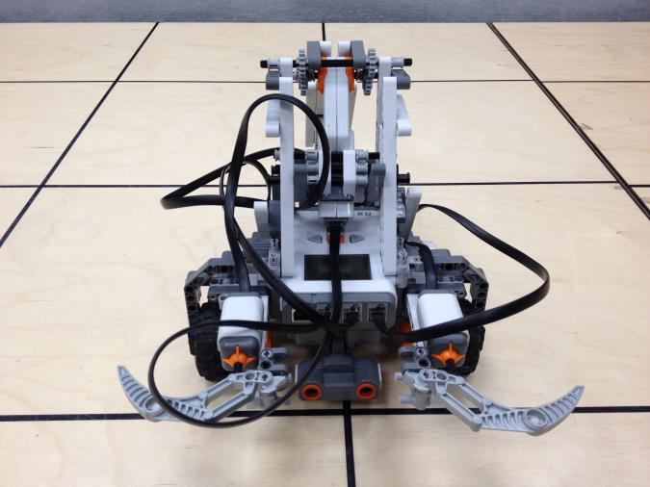

Figure - Front-Top View

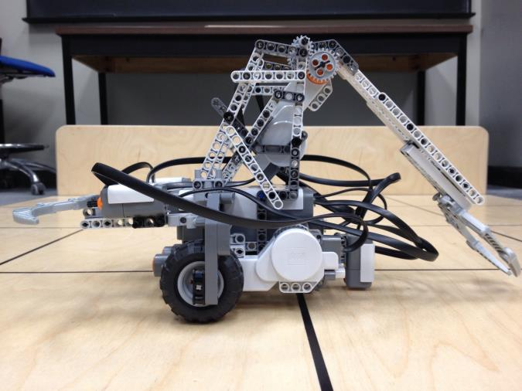

Figure - Left Side View

* + Stability

Currently, the robot is supported by the two side wheels with tires and a third bare plastic wheel in the back end. The stability of the robot while in still or in motion (moving in the plane) is solid (awaiting further tests). However, as the robot releases its catapult mechanism, and due to the sheer force applied, the robot tends to tip forward immediately after the ball is launched. Depending of the exact motion, the robot will slightly deviated from its coordinates in the plane and may also completely tip forward onto its front. (awaiting hardware team’s solution and further testing)

* + Wheels

Two of the wheels are standard wheels with tires as provided in the kit. One of the wheels (attached to the back end) is not attached to any motors and is bare plastic and of a smaller diameter.

A possible improvement would be to integrate Play-Doh (or equivalent) inside the tires to make them more solid and less prone to deformation and slippage.

* Sensors
  + Light Sensor

One light sensor is used in the design for both the localization and odometry correction segments of the challenge. The light sensor is attached at the back end of the robot and points straight down where its sensory tip is parallel to the ground. The tip of the sensor is placed relatively low compared to the other sensors in order to potentially reduce the effects of lighting condition variations and also allow for shorter ping times (To be verified with tests). One issue is that because it is so close to the floor, the uneven panels which comprise the competition surface might actually come in contact with the tip of the sensor (Testing would confirm any such issues).

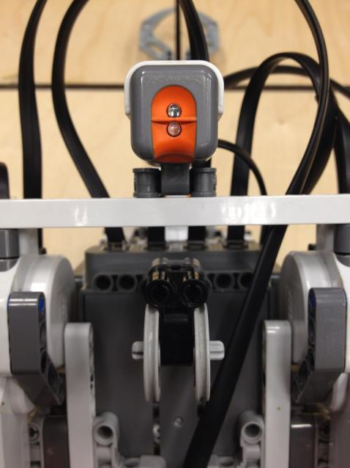

Figure - Bottom View (Detail: Light Sensor & Third Wheel)

* + Ultra-sonic Sensor

The Ultra-sonic Sensor is placed at the front end of the robot and points straight ahead. The sensor sits at the bottom half of the base and is quite low. One change that is in the works is an alternative placement of the sensor at a higher vantage point. This would prevent the sensor from picking up a potentially large amount of noise coming from the uneven seams in the competition floor. The current design place the sensor in a permanently fixed position with no possibility of motion.

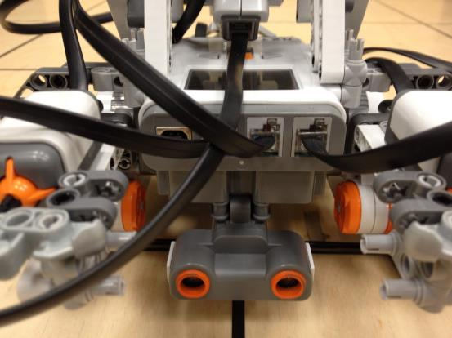

Figure 4 - Front View (Detail: US Sensor)

* + Touch Sensors

The touch sensors (2) are attached on the front-left and front-right corners of the robot. The tip of both sensors face forward and point away from the robot. The sensors are used detect potential collisions with objects and are meant to signal the NXT system of such collisions. To ensure that the touch sensors can detect such collisions from the widest range of directions is by attaching a mobile claw-shaped arm piece right in front of each touch sensor. When the claw comes into contact with a surrounding object, the claw will be pushed back by the collisions force onto the touch sensor’s trigger. The claw is then depressed and returns to its initial position when the robot is cleared from any obstacles.

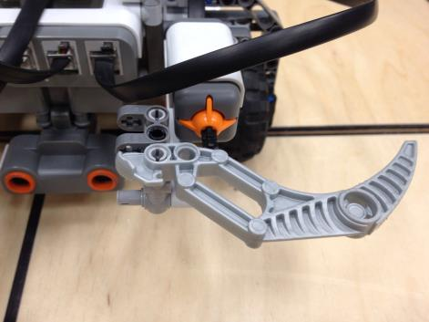

Figure 5 - Front View (Detail: Touch Sensor)

* Catapult mechanism

The catapult mechanism is so far the most complex mechanical design feature of the prototype system. The servo motor, which is mounted diagonally with its port facing downwards towards the body of the robot and its orange rotating tip facing upwards and away from the NTX brick, is structurally maintained in place by a relatively sturdy connection of long and short stem Lego pieces. The sound structural base and tower on which this motor sits is extremely crucial due to the force which the catapult mechanism will undoubtedly exert on its surrounding pieces. To add to the complexity of the design, the motor is not attached directly to the rest of the catapult arm (and ball-cupping claw). Instead, 2 pairs of gears are used as an intermediate mechanism for controlling the motion of the claw with precision. A pair of gears, with comparatively larger diameters, are placed on either side of the rotating motor tip and are then each paired with a gear with a smaller diameter.

On issue with the design is often manifested when the gears are in quick motion and the motor is actually pushed downwards causing the gears to lose close contact and cause a “jump” in the cogs (A solution is being developed and may involve either solidifying the motor support or modifying the gear system in a more dramatic way)

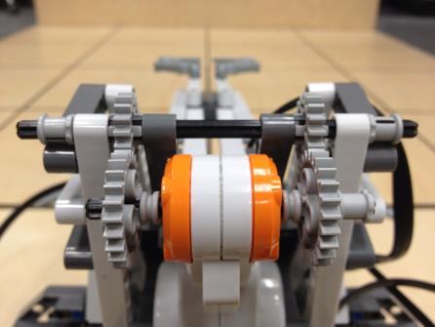

Figure 6 - Front View (Detail: Catapult Mechanism Motor)

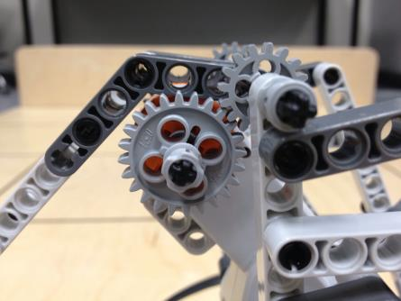

Figure 7 - Right Side View (Detail: Catapult Mechanism Gears)

* Ball retrieval system

“detailed drawing of the dispenser and the feeder mechanism will be posted on WebCT”

and has not yet been integrated in current prototype design.

* Defense system

At present, the defense mechanism is limited to a “passive” system in which the robot will mechanically raise its catapult arm to a vertical upright position and maintain the position. The relatively long arm of the catapult design should limit the area at which opposing attacking teams can aim at. A more sound and “aggressive” defense solution will be discussed as the hardware team continues to finalize the attacking mechanisms.

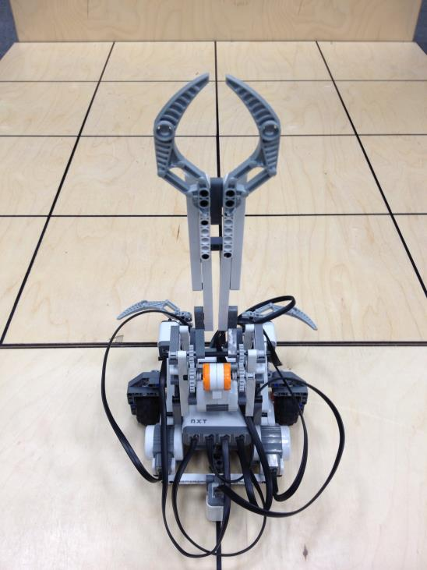

Figure 8 - Back View (Defense Position)

**OTHER FIGURES**

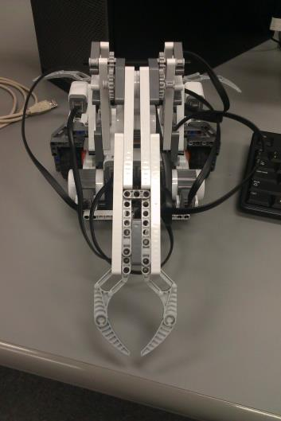 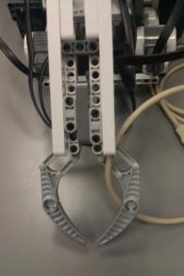 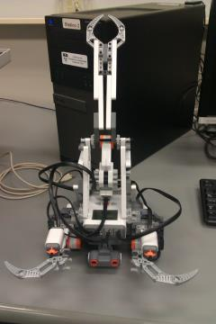 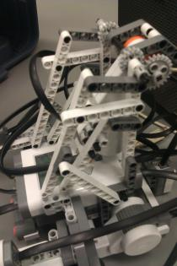

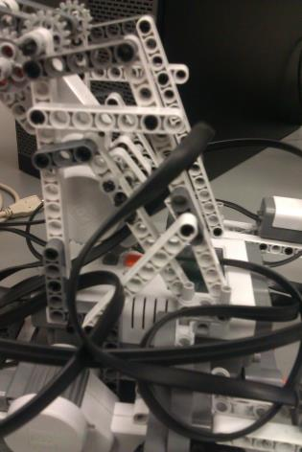 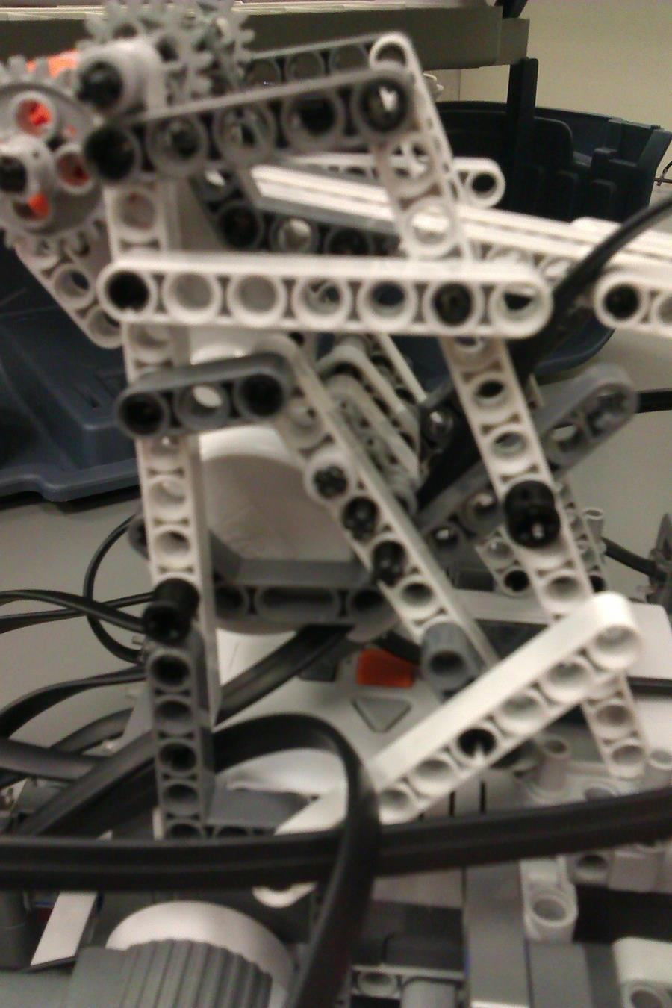 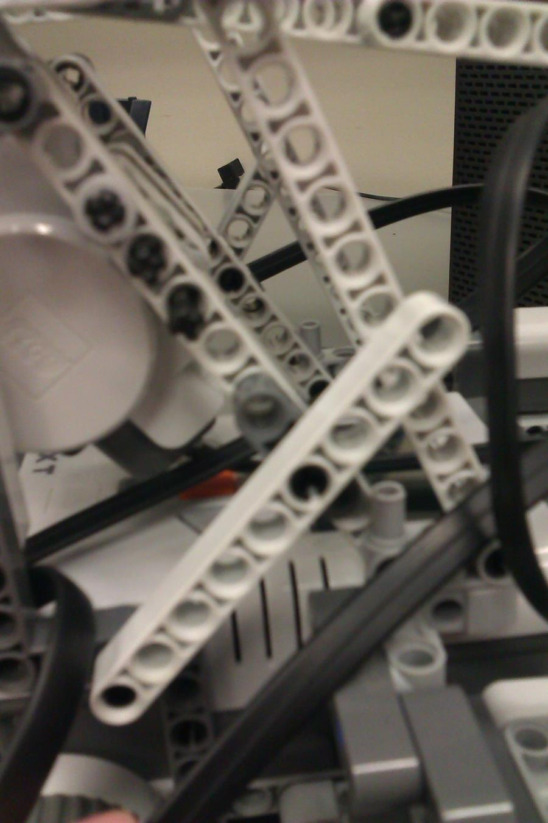 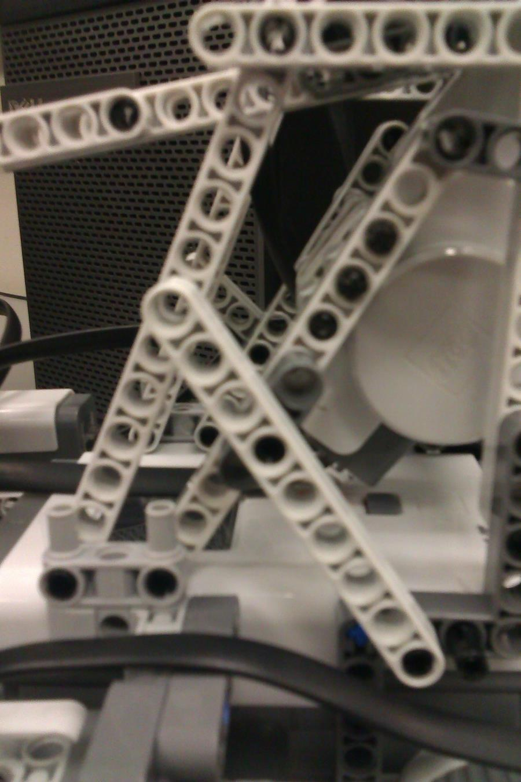

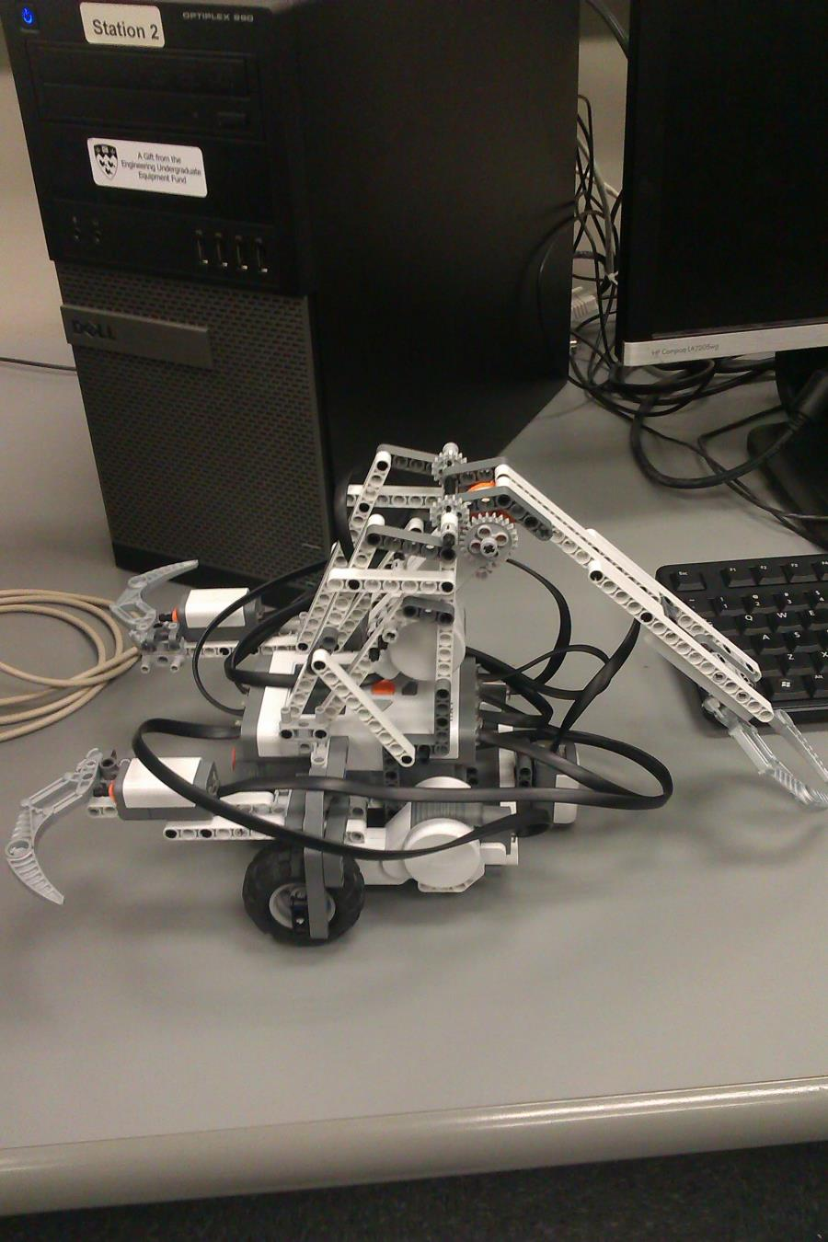 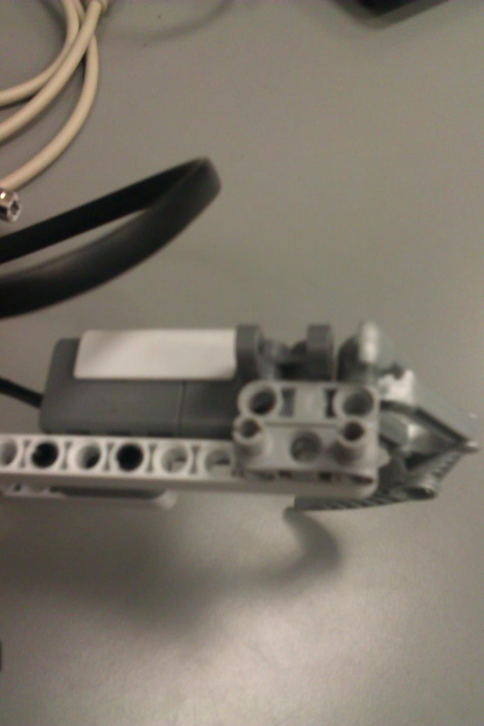 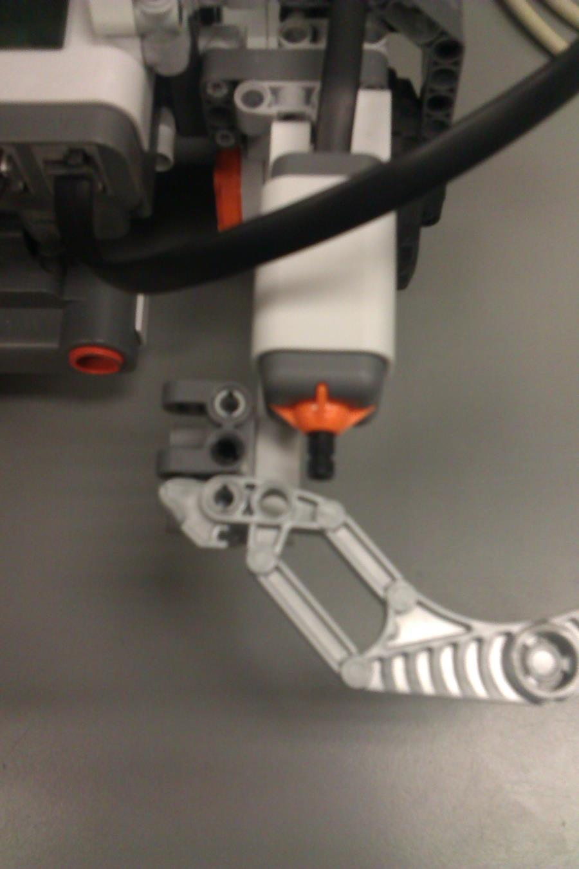 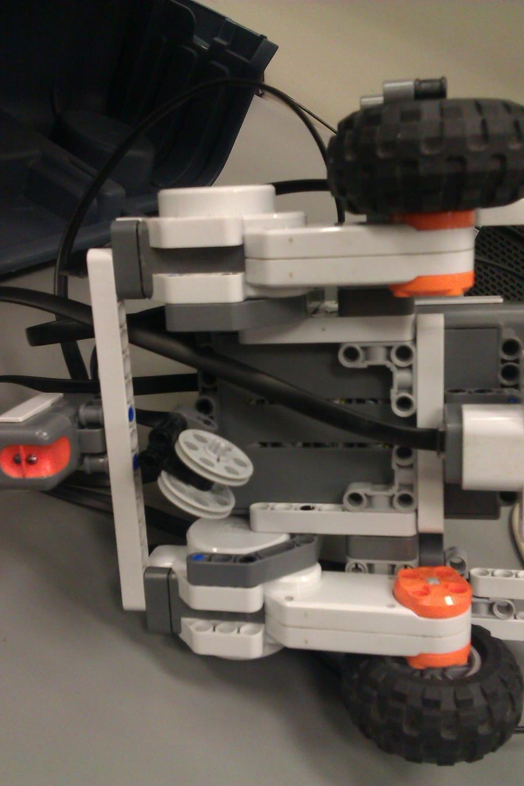

**DEFINITIONS AND TERMINOLOGY**